- What is an economy? What roles do production, distribution, and consumption play in an economy?

- Describe supply and demand. Draw the supply and demand graph.

- Draw the supply chain for retail stores.

- Draw the supply chain for local markets.

- What are the benefits of selling/buying from local markets?

- Determine the total production costs of growing corn on 10 acres by completing the table below.

COSTS | Cost per Acre | Cost per 10 Acres
Seeds | $100
Land/Fertilizer | $500
Water | $60
Labor (5 workers) | $600
TOTAL

- Determine the GROSS PROFIT of 10 acres of corn when the GROSS PROFIT of one acre of corn is $3,400.

- Determine the maximum NET PROFIT of 10 acres of corn before your crop goes to market.

- Calculate your NET PROFIT if you were to sell to Wal-Mart (16% of net profit from #3) and a local market (100% of net profit from #3).
 | Wal-Mart | Local Market
Net Profit

- Which market from question #4 is MOST PROFITABLE for you to sell your corn?

- When you sell to a retailer (like Wal-Mart), what additional costs arise?

- What is an economy? What roles do production, distribution, and consumption play in an economy?
An economy is the system by which goods and services are produced, sold and bought that helps us determine how to use limited resources. Production is what gets made and how; distribution is how we get those goods to those who want them; and consumption is what people want, how much they want, and what price they are willing to pay for goods and services.
- Describe supply and demand. Draw the supply and demand graph.
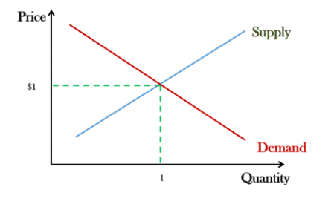
Supply is how much of something is available and demand is how much of something is wanted.

- Draw the supply chain for retail stores.
Farmer -> Processor -> Distributor -> Retailer -> You (Consumer)

- Draw the supply chain for local markets.
Farmer -> Market -> You (Consumer)

- What are the benefits of selling/buying from local markets?
Farmers have a place to sell their food locally
Local farmers get to keep more money, which stays in the community.
You get to eat tasty, local and healthy food

- Determine the total production costs of growing corn on 10 acres by completing the table below.

COSTS | Cost per Acre | Cost per 10 Acres
Seeds | $100 | $1,000
Land/Fertilizer | $500 | $5,000
Water | $60 | $600
Labor (5 workers) | $600 | $6,000
TOTAL | $1,260 | $12,600

- Determine the GROSS PROFIT of 10 acres of corn when the GROSS PROFIT of one acre of corn is $3,400.
$3,400/acre * 10 acres = $34,000/10 acres
GROSS PROFIT = $34,000
- Determine the maximum NET PROFIT of 10 acres of corn before your crop goes to market.
Gross Profit – Production Costs = Net Profit
$34,000 - $12,600 = $21,400
NET PROFIT = $21,400
 | Wal-Mart | Local Market
Net Profit | $21,400 * 0.16 = $3,424 | $21,400
- Calculate your NET PROFIT if you were to sell to Wal-Mart (16% of net profit from #3) and a local market (100% of net profit from #3).

- Which market from question #4 is MOST PROFITABLE for you to sell your corn?
LOCAL MARKET!
- When you sell to a retailer (like Wal-Mart), what additional costs arise?
Everyone who touches the corn gets a piece of the profit, including the processor, distributor, retailer and transportation company.

